日本語リクエストフォーム

|  |  |  |  |  |  |
| --- | --- | --- | --- | --- | --- |
|  | **物品名(写真参照)** | **貸し出し可能な数** | | **希望に**  **「✓」** | **詳細を記載**  **例：法被　赤M２着** |
| **1** | 生花の花瓶 | 16 | |  |  |
| **2** | 浴衣 | 女　3 | 男　3 |  |  |
| **3** | 法被 | 青　7  (Mサイズ) | 赤　7  (S サイズ 3)  (M サイズ 4) |  |  |
| **4** | 餅つきセット | 1 | |  |  |
| **5** | 座布団 | 2 | |  |  |
| **6** | 鯉のぼりセット | 1 | |  |  |

|  |  |
| --- | --- |
| 担当者名 |  |
| 所属機関・学校 |  |
| 住所 |  |
| 連絡先（電話、メール） |  |
| 使用目的 |  |

上記物品の借用を希望します。借りる際には規則を守り、決められた期間内に返却します。

|  |  |  |
| --- | --- | --- |
| 受付日  （受付日に記入） | 年　　月　　日 | 総領事館によるサイン： |

|  |  |  |
| --- | --- | --- |
| 返却日  （返却日に記入） | 年　　月　　日 | 総領事館によるサイン： |

English Request Form

|  |  |  |  |  |  |
| --- | --- | --- | --- | --- | --- |
|  | Item List  (see next page) | Available number of items | | Put ✓ | Details　(Ex. Happi set,1 red M) |
| 1 | Ikebana flower vase | 16 | |  |  |
| 2 | Yukata | Men　3 | Women　3 |  |  |
| 3 | Happi coat | Blue　7  (M size) | Red　7  (S size　3)  (M size　4) |  |  |
| 4 | Mochi pounding set | 1 |  |  |  |
| 5 | Zabuton (sitting cushion) | 2 | |  |  |
| 6 | Koinobori set | 1 | |  |  |

|  |  |
| --- | --- |
| Name of the person-in-charge |  |
| Organization/School |  |
| Address |  |
| Contact (Phone, Email) |  |
| Purpose of use |  |

I request to borrow the above items. We will comply with the rules and regulations when borrowing the items and return them within the stipulated period.

|  |  |  |
| --- | --- | --- |
| Date received  (Fill up on the date of receive) | mm/dd/yyyy | Signature of the Consulate staff: |

|  |  |  |
| --- | --- | --- |
| Date returned  (Fill up on the date of return) | mm/dd/yyyy | Signature of the Consulate staff: |

1. Ikebana flower vase（生花の花瓶）

|  |  |  |  |
| --- | --- | --- | --- |
| Green 1 | Green 2 |  |  |
|  |  |  |  |
| Lantern | Genie’s Lamp   |  | Dirty Brown |
|  | Basin (rectangle) | Basin (round)   | Basin (oval)   |

1. Yukata（浴衣）

|  |  |  |  |
| --- | --- | --- | --- |
| Female |  |  | Yukata 3 |
| Male | Yukata 4 |  | Yukata 6 |

1. Happi set（法被）

|  |  |  |  |
| --- | --- | --- | --- |
| Color | Size | Number of items |  |
| Red | S  M | 3  4 |  |
| Blue | M | 7 |  |

1. Mochi pounding set（餅つきセット）

1. Zabuton（座布団）

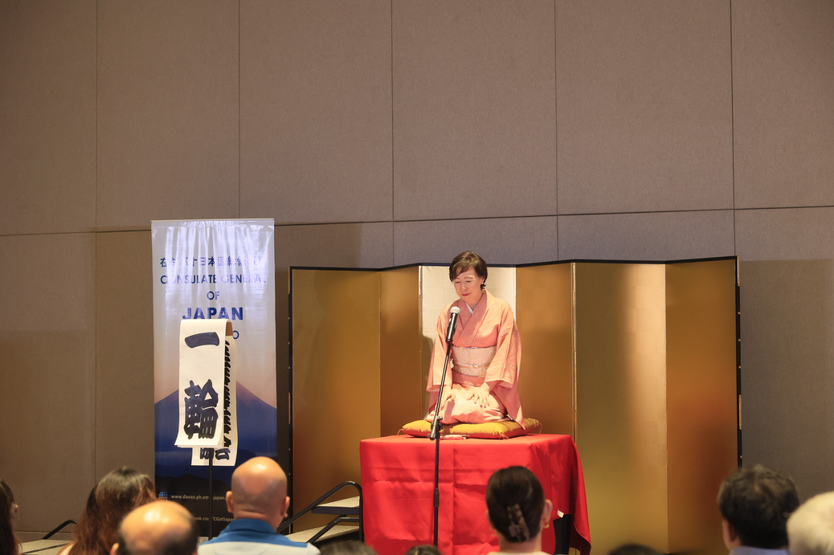

1. Koinobori set （こいのぼりセット）

